Execute the sql queries for different dataset
Dataset
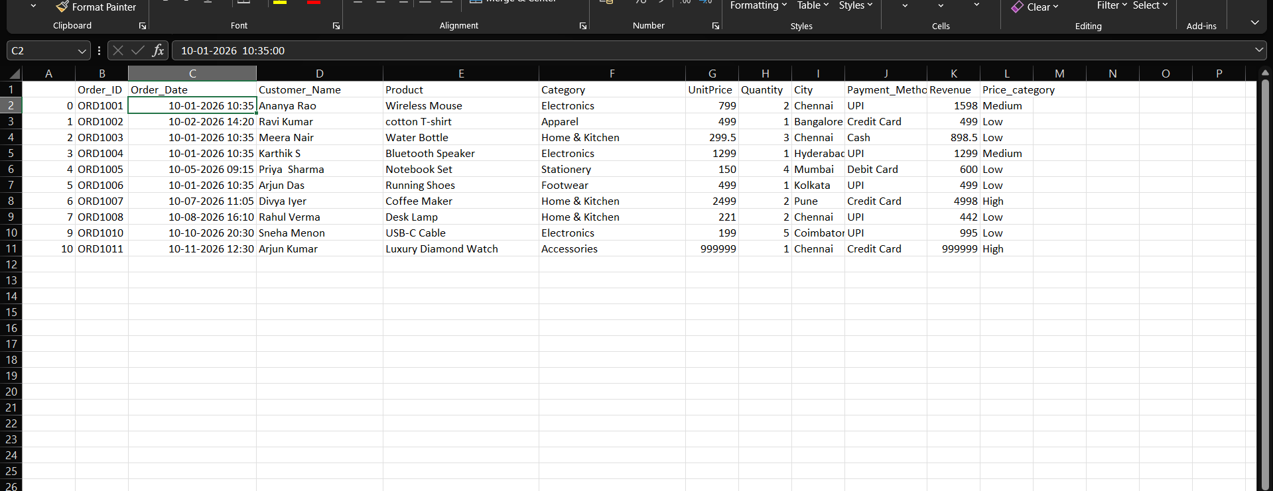

Table | Columns | Purpose
Customers | Customer_ID, Customer_Name, City | Stores customer information
Products | Product_ID, Product_Name, Category, UnitPrice, Price_Category | Stores product information
Orders | Order_ID, Customer_ID, Product_ID, Order_Date, Quantity, Payment_Method, Revenue | Stores order transactions

1. Which product categories generate the highest revenue?
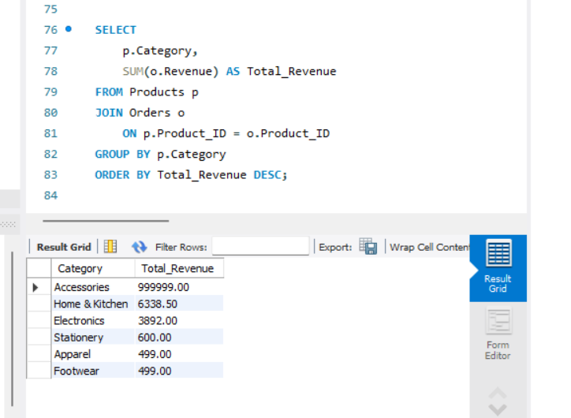
2. Which customers spend the most?
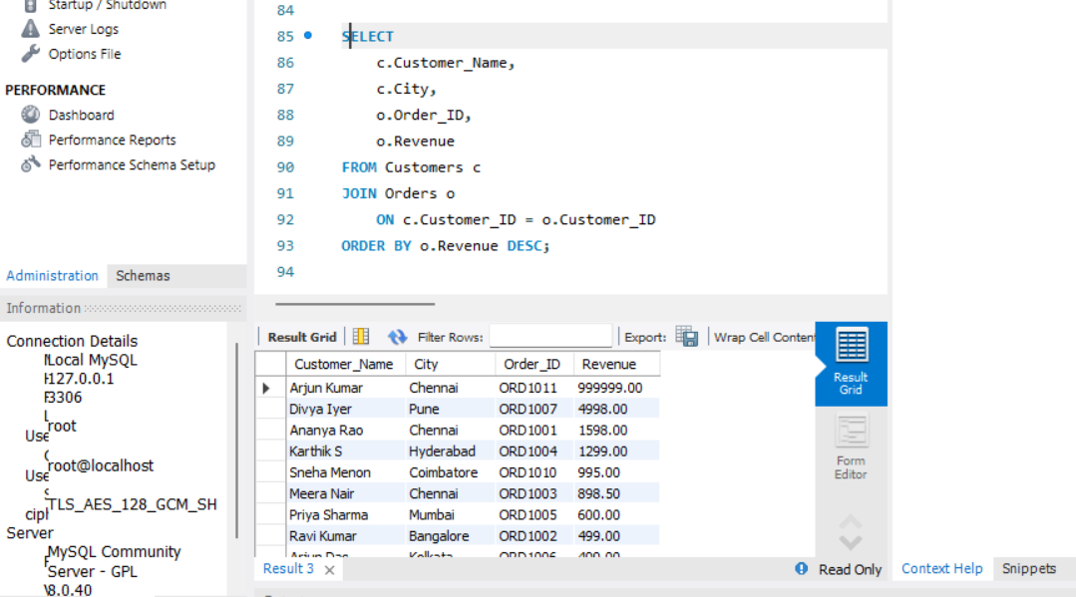

3. : What is the total revenue generated?
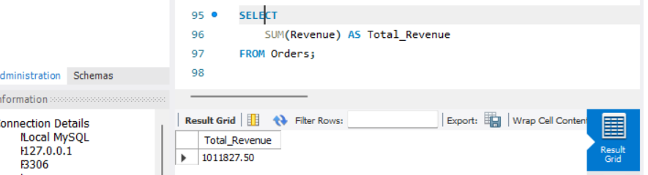
4. What is the average order value?
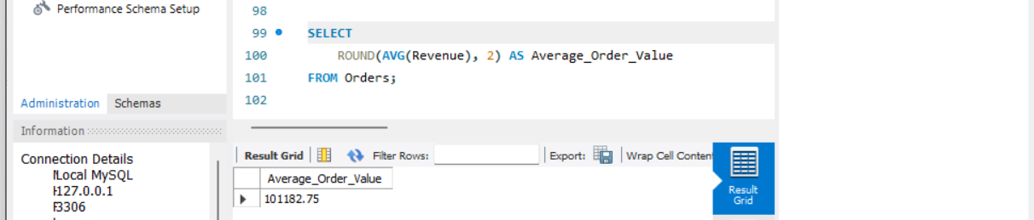

5. Which orders have revenue greater than 1000?
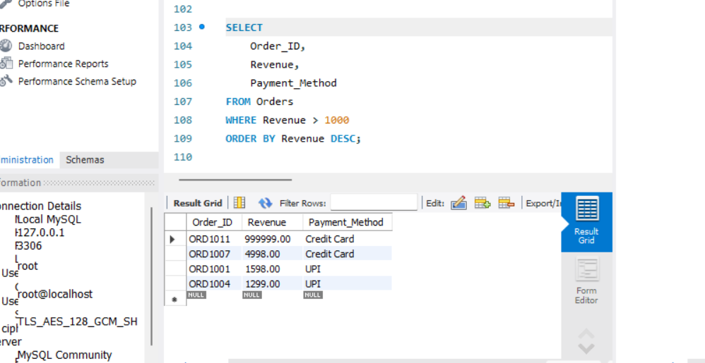

6. How many orders were placed using each payment method?
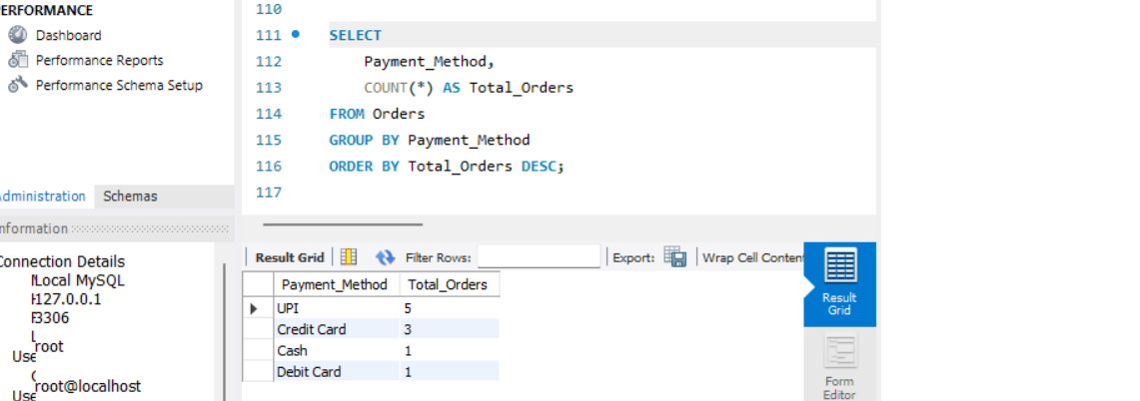

7. Which products are priced above the average product price?
